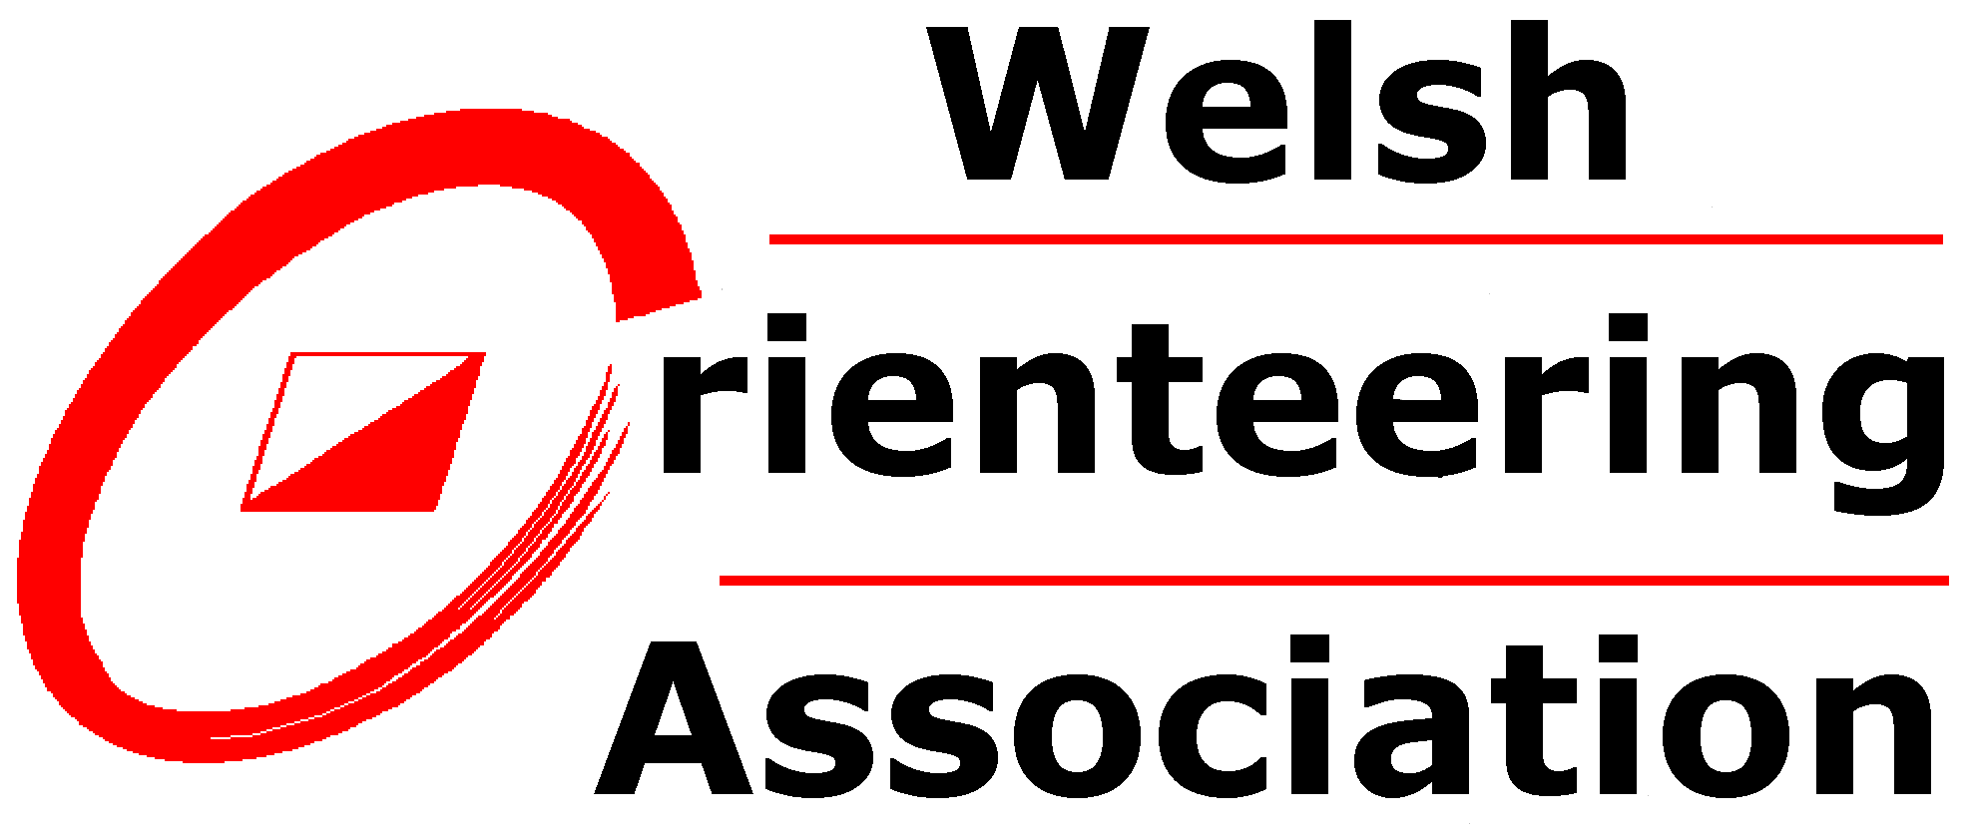
WOA Competition Rules - Welsh Orienteering League

Document active from January 2021
This document explains the rules relating to clubs running a Welsh Orienteering League event and competitors running in these events. This is the first version of a document drawing together all the applicable rules in one place, as previously a number of documents would need to be consulted to achieve the same.
Text in bold has mandatory status. This must be followed by event officials and competitors unless a variation has been obtained. Variation may be requested from the British Orienteering Events and Competitions committee via the Welsh Orienteering Association (WOA) for events registered at National Level (Level B) or Major Level (Level A), or directly from WOA for events registered at Regional Level(Level C).
These WOA Rules must be used in conjunction with the British Orienteering Rules of Orienteering and Appendices. Where the WOA Rules vary or supplement British Orienteering Rules of Orienteering, then these Competition Rules will take precedence.
Next review date January 2024
1. General information
1.1 The competition is run on a calendar year in order to avoid confusion over age class changes.
1.2 The events making up the competition is for individual runners based on foot orienteering run in day light only. It may include mass-start races for individual competitors registered at the correct level as long as the courses offered allow matching against the colour or age class course weightings as stated in 3.11. It will not include non-linear races such as score races, or relay legs.
1.3 All events registered with British Orienteering at Regional, National or Major Level taking place in Wales can be considered for inclusion. A club can request that their event not be included in the Welsh Orienteering League by contacting the Welsh League co-ordinator in advance of the event. Only events running courses that can be matched against the Welsh League scoring weightings can be included in the league.
1.4 If a race is postponed and subsequently run within the same calendar year it can still be included in the Welsh League for that year. If a race is postponed to a subsequent year it can be included in the new calendar year only and not used retrospectively in the original year it was registered for.
1.5 If a race is cancelled and not subsequently run then it is no longer included in the Welsh Orienteering League.
1.6 A Welsh Orienteering League race may also be included in any other competition that the host club, or WOA decide they wish to. Examples include heats of the Yvette Baker Trophy or the UK Urban League.
2. Responsibility
2.1 Host clubs are requested to include the wording “Year Welsh Orienteering League Event” in their promotion of their race in any format they decide to use.
2.2 The WOA fixtures secretary in conjunction with the Welsh League Co-ordinator is responsible for identifying suitable races to be included in the Welsh League and approaching the host club to confirm their approval. A host club can request inclusion in the Welsh League with the WOA fixtures secretary prior to an approach from the WOA fixtures secretary.
2.3 Welsh League races are to be listed on the WOA website at least three months in advance of the race taking place.
2.4 All Welsh League races must have a controller appointed. It is the host clubs responsibility to appoint a controller. The controller should be from a club other than the host club and can be a controller from outside WOA as long as they are a member of BOF. Where difficulty arises in appointing a controller clubs are asked to contact WOA committee at least three months before the race for assistance in resolving this. Clubs can approach WOA committee for assistance with paying controllers expenses when the condition for appointing a controller from outside the host club adversely affects the finances of the event. Finalised accounts will be required before a full or part payment can be made.
2.5 WOA reserves the right to withdraw a Welsh League race from an event where it is unsatisfied with a clubs progress in hosting the race. The race may continue but may be subject to consideration of downgrading by WOA where this is felt to be in the best interest of WOA members.
3. Eligibility and Scoring
3.1 A person must be a member of WOA at the time a particular race takes place for their score to be included in the Welsh League for that and any subsequent races in that calendar year. For any race that has been postponed prior to the person joining WOA and is then run later by which time the member has joined WOA their score can be included in the league for that year.
3.2 A person may join WOA on the day of a race and their score for that race to be included in the league. Clubs are requested to submit membership details to the WOA membership secretary within four days of the race to allow the most accurate list to be available to the Welsh League Co-ordinator.
3.3 A person who joins WOA after the Welsh League has started cannot have races prior to their membership starting included in their league score for that year. If a WOA member changes club within a year they will still be eligible for the scores achieved with their previous club to be included in their yearly score for that year. It is the competitors responsibility to ensure the WOA membership secretary is aware of any change of club. This is a change from the scoring method used in recent years where competitors could join at any time of the year and receive all their event scores for that year even though they were not a member at the time of the races. The current scoring mechanism is unable to respond to the changes in 3.3 and until it is modified a manual deletion of scores may be required.
3.4 A person is expected to be a member of British Orienteering (BOF) in order to take part in races at Regional, National or Major Level. They can be a member of an association other than WOA to run at the races, but must be a WOA member to be included in the Welsh League. As long as the person is a member of BOF they will be eligible for any BOF ranking points where this applies even if they are not a member of WOA.
3.5 Runners must declare when registering for a race if they intend to be shadowed so they can be listed as non-competitive in the final results and not included in the Welsh League for that race.
3.6 Two junior runners may run together on the Yellow or Orange course, and still be competitive for the Welsh League as long as 3.1 is met for both. This should be achieved by both runners entering separately, each using a SI dibber allocated to them and both being given the same start time. Both runners names and age classes must included in the results for that race. Each runner will receive the appropriate points for their run. The same pair does not need to run together at subsequent races. They can run as different pairs on Yellow or Orange courses at subsequent races but may only run competitively once at any single Welsh League race. Each runner will still remain competitive as long as all the conditions listed in 3.6 are met.
3.7 The Welsh League will comprise the following categories,
- Male and Female Junior- which will be M/W 18-
- Male and Female Senior- which will M/W20, M/W 21 and M/W35
- Male and Female Veteran-which will be M/W40 and M/W45
- Male and Female Super Veteran- which will be M/W50, M/W55 and M/W60
- Male and Female Ultra Veteran- which will be M/W65+
3.8 The WOA Equality and Inclusion Policy will be used to determine gender for the League categories.
3.9 A competitor’s best five scores will be used to determine their league score after the final league race unless there have been less than five races in a year, when all their accumulated score will be used. See 3.3 as only scores while a member of WOA can count.
3.10 Where two or more competitors maybe eligible for a prize and have the same final score then they will be declared joint prize winner.
3.11 Scoring will be worked out on the following basis using a weighting system based on course class and age class using the following equation
Winners time X100 X Course Weighting X Class Weighting
Your time

Course Weightings
Black | 1.10
Brown | 1.00
Short Brown | 0.90
Blue | 0.80
Short Blue | 0.70
Green | 0.60
Short Green | 0.50
V Short Green | 0.45
Light Green | 0.50
Long Orange | 0.43
Orange | 0.37
Yellow | 0.30
White | 0.24

Mens Class Weightings |  | Womens Class Weightings
M10 | 3.5 | W10 | 4.0
M12 | 2.5 | W12 | 3.0
M14 | 2.0 | W14 | 2.5
M16 | 1.5 | W16 | 2.0
M18 | 1.3 | W18 | 1.7
M20 | 1.1 | W20 | 1.6
M21 | 1.0 | W21 | 1.4
M35 | 1.1 | W35 | 1.6
M40 | 1.2 | W40 | 1.7
M45 | 1.3 | W45 | 1.8
M50 | 1.5 | W50 | 1.9
M55 | 1.6 | W55 | 2.0
M60 | 1.8 | W60 | 2.2
M65 | 2.0 | W65 | 2.4
M70 | 2.2 | W70 | 2.6
M75 | 2.4 | W75 | 2.8
M80 | 2.6 | W80 | 3.0
M85 | 2.8 | W85 | 3.2

4. Course planning
4.1 When colour courses are being used clubs are requested to offer the following minimum courses, Blue, Green, Short Green, Light Green, Orange and Yellow. Where an area allows other colour courses to be offered then they may offer any of the colours as stated in the course weighting table in 3.11. If additional course colours not listed in the course weighting table 3.11 are being offered, clubs should notify the Welsh League scorer in advance of the event, to enable a weighting to be assigned where possible. Clubs may offer any other courses they feel appropriate but these may not be included in the Welsh League scoring. When a colour coded event is combined with home internationals where there is an additional age category course that does not map onto a standard Welsh League colour course, the club must inform the Welsh League scorer of the technical difficulty and how it compares to the standard colours in advance of the event. Clubs are asked to make it clear in pre event details any courses being offered that will not count towards Welsh League scoring.
5. Map
5.1 The map must comply with all the relevant requirements in the British Orienteering Rules of Orienteering Section 18 and Appendix D: Mapping
6. Safety
6.1 Event Officials must refer to British Orienteering Rules of Orienteering and Appendix E: Event safety for detailed information on the required and recommended safety and risk management procedures.
7. Trophies and Prize Giving
7.1 The Welsh League Co-ordinator will arrange for the first three competitors in each category(including joint prize winners where this applies) to receive an appropriate memento and/or certificate to include the wording “Welsh League” “First”, “Second” “Third” as appropriate, the year of competition and the category competed in.
7.2 Competitors may receive a prize in only one category in any one year.
7.3 Where possible, awards will be presented to prize winners at the first Welsh League race of the subsequent year. Competitors who believe they are eligible for an award may contact the Welsh League Co-ordinator to arrange collection of their prize if they miss the presentation.
8. Disputes and concerns
8.1 Concerns about the Welsh League should be raised with the Welsh League Co-ordinator in the first instance. They can be contacted at welshleague@woa.org.uk
8.2 If 8.1 does not resolve the concern then the matter can be raised with the WOA committee through the WOA Secretary in line with the WOA Complaints Procedure (once it has been developed). WOA’s decision can be appealed if required by requesting the matter is raised by WOA committee with BOF. BOF’s decision on any matter is final.

